<Project Name>
Test Case
Version <5.0>
<01/23/2023>

VERSION HISTORY

Version  # | Implemented  By | Revision  Date | Approved  By | Approval  Date | Reason
1.0 | Alina Kharkevich | 01/19/23 | Alina Kharkevich | 01/19/23 | Test Case Template “View orders list”, Test Case document base
2.0 | Lizaveta Babior | 01/20/23 | Alina Kharkevich | 01/20/23 | Test Case Template “View personal data”
3.0 | Daria Dronova | 01/22/23 | Alina Kharkevich | 01/22/23 | Test Case Template “Change order status”
4.0 | Anastasiya Sukach | 01/22/23 | Alina Kharkevich | 01/22/23 | Test Case Template “View the status of the order”
5.0 | Alina Kharkevich | 01/23/23 | Alina Kharkevich | 01/23/23 | Lat check and improvements, style changes
UP Template Version: 01/23/2023

TABLE OF CONTENTS

1.1 INTRODUCTION TO “VIEW ORDERS LIST” 5
1.1.1 Purpose of The Document 5
2.1 TEST CASE “VIEW ORDERS LIST” SPECIFICATION 5
2.1.1 Description 5
2.1.2 Resources 6
2.1.3 Preconditions 6
2.1.4 Post Conditions 6
2.1.5 Flow of Events 6
2.1.6 Inclusion/Exclusion Points 6
2.1.7 Special Requirements 6
2.1.8 Use-case scenario 6
2.1.9 Test case “View orders list” 7

1.2 INTRODUCTION TO “VIEW PERSONAL DATA” 9
1.2.1 Purpose of The Test Case Document 9
2.2 TEST CASE “VIEW PERSONAL DATA” SPECIFICATION 9
2.2.1 Description 9
2.2.2 Resources 10
2.2.3 Preconditions 10
2.2.4 Post Conditions 10
2.2.5 Flow of Events 10
2.2.6 Inclusion/Exclusion Points 10
2.2.7 Special Requirements 10
2.2.8 Use-case scenario 10
2.2.1 Test case “View Personal Data” 11

2.3 INTRODUCTION TO “CHANGE ORDER STATUS” 12
1.1.2 Purpose of The Test Case Document 12
2.4 TEST CASE “CHANGE ORDER STATUS” SPECIFICATION 12
2.2.1 Description 12
2.2.9 Resources 13
2.2.10 Preconditions 13
2.2.11 Post Conditions 13
2.2.12 Flow of Events 13
2.2.13 Inclusion/Exclusion Points 13
2.2.14 Special Requirements 13
2.2.15 Use-case scenario 13
2.4.1 Test case “Change order status” 14

1.1 INTRODUCTION TO “VIEW THE STATUS OF THE ORDER” 15
1.1.3 Purpose of The Test Case Document 15
2.5 TEST CASE “VIEW THE STATUS OF THE ORDER” SPECIFICATION 15
2.5.1 Description 15
2.5.2 Resources 16
2.5.3 Preconditions 16
2.5.4 Post Conditions 16
2.5.5 Flow of Events 16
2.5.6 Inclusion/Exclusion Points 16
2.5.7 Special Requirements 16
2.5.8 Use-case scenario 16
2.5.9 Test Case “View the status of the order” 17

A. APENDIX REFERENCES 19

INTRODUCTION TO “VIEW ORDERS LIST”

Purpose of The Document
The Test Case document documents the functional requirements of the “View orders list” test case. The intended audience is the project manager, project team, and testing team. Some portions of this document may on occasion be shared with the client/user and other stakeholder whose input/approval into the testing process is needed.

TEST CASE “VIEW ORDERS LIST” SPECIFICATION

Description
The following section includes Use-Case Diagram, Use-Case Description, Test Case Description and Test Case Specifications.

Use-Case Diagram:
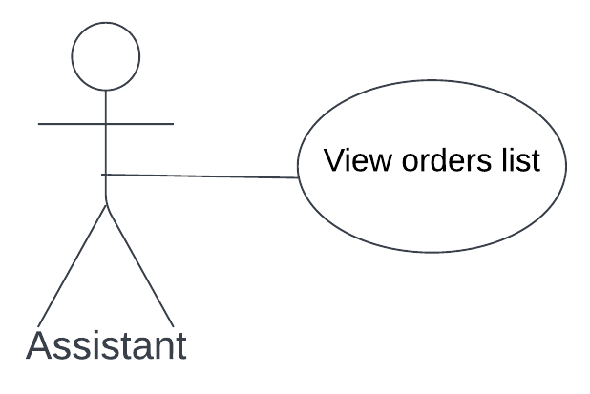
Use-Case Description:
The Assistant views the list of all orders of the Pick-up Point. (Xref: 06.X.X)
Test Case Description:
The purpose of this test case is to validate that the system allows the Assistant to view the list of all orders of the Pick-up Point without any issues. The “View orders list” Use-Case requires testing to ensure that correct list of orders displays in time at the request of the User authenticated as valid User role Assistant.
Test Case Specifications:
Test Case ID: Fun_02
Test Case Name: View orders list
Test Case Title: View the list of all orders of the Pick-up Point.
Test Case Priority (Low/Med/High): Low
Test Case Description: Test the “View orders list” functionality in order to detect any defects in displaying and viewing the correct list of all orders of the Pick-up Point.

Resources
The Testers team responsibilities, revolves around identifying each combination of basic and alternate flows to help in the process of creating test cases for the “View orders list” Use-Case. The association to the test case: User role of the Assistant.

Preconditions
- The User has been authenticated and authorized as a valid User of role Assistant. (Xref: 06.X.X)

Post Conditions
- The list of orders appeared on the screen. (Xref: 06.X.X)

Flow of Events
Basic Path | - The Assistant clicks on the button „My Account”.  - The Terminal displays My Account Page.  - The Assistant chooses the option “View Orders List”.  - The Terminal displays the list of orders with payment info on the screen.
Alternative Path | 4.a.1 The Terminal displays the empty list.
(Xref: 06.X.X)

Inclusion/Exclusion Points
Incusion points:
Test Case ID: Fun_01
Test Case Name: Log in
Test Case Title: Log in as a valid User of role Assistant or Customer.
*in this case, User of role Assistant

Special Requirements
The Guest needs to log into the system as a valid User of role Assistant in order to use “View order list” functionality.

Use-case scenario
Scenario Name | Starting Flow | Alternative Flow
Scenario 1 – Successful Standard | Basic Path | -
Scenario 2 – Successful Non-standard | Basic Path | Alternative Path 1

Test case “View orders list”

Scenario 1 – Successful Standard
Step | Test Steps | Test Data | Expected Result | Actual Result | Process Success (Pass/Fail) | Notes
1 | Clicks on the “My Account” button. | - | The “My Account” button should be pressed without any errors. | The “My Account” button successfully clicked | Pass | -
2 | Navigate to My Account Page. | Link: https://www.  myaccount  .com | Should be redirected to My Account Page in time without any errors. | Successfully redirected to My Account Page in time. | Pass | -
3 | Clicks on the “View Orders List” button. | - | The “View Orders List” button should be pressed without any errors. | The “View Orders List” button successfully clicked | Pass | -
4 | Navigate to View Orders List Page. | Link:  https://www.  orderslist  .com | Should be redirected to View Orders List Page in time without any errors and all orders correctly displayed. | Successfully redirected to View Orders List Page in time and all orders correctly displayed. | Pass | Scenario 1 – Successful Standard

Scenario 2 – Successful Non-standard
Step | Test Steps | Test Data | Expected Result | Actual Result | Process Success (Pass/Fail) | Notes
1 | Clicks on the “My Account” button. | - | The “My Account” button should be pressed without any errors. | The “My Account” button successfully clicked | Pass | -
2 | Navigate to My Account Page. | Link: https://www.  myaccount  .com | Should be redirected to My Account Page in time without any errors. | Successfully redirected to My Account Page in time. | Pass | -
3 | Clicks on the “View Orders List” button. | - | The “View Orders List” button should be pressed without any errors. | The “View Orders List” button successfully clicked | Pass | -
4 | Navigate to View Orders List Page. | Link:  https://www.  orderslist  .com | Should be redirected to View Orders List Page in time without any errors and page is empty, without any orders. | Successfully redirected to View Orders List Page in time and page is empty, without any orders. | Pass | Scenario 2 – Successful Non-standard

1.2 INTRODUCTION TO “VIEW PERSONAL DATA”

Purpose of The Test Case Document
The Test Case document documents the functional requirements of the “View personal data” test case. The intended audience is the project manager, project team, and testing team. Some portions of this document may on occasion be shared with the client/user and other stakeholder whose input/approval into the testing process is needed.

TEST CASE “VIEW PERSONAL DATA” SPECIFICATION

2.2.1 Description
The following section includes Use-Case Diagram, Use-Case Description, Test Case Description and Test Case Specifications.

Use-Case Diagram:
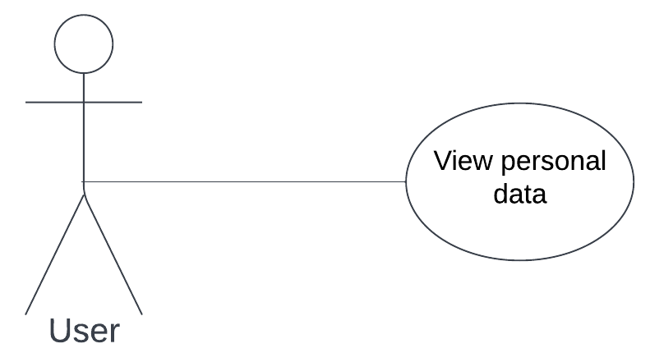
Use-Case Description:
The Customer views his Personal Data. (Xref: 02.X.X)
Test Case Description:
The purpose of this test case is to validate that the system allows the User to view his Personal Data without any issues. The “View Personal Data” Use-Case requires testing to ensure that correct list of information displays in time at the request of the User authenticated as valid User role Customer or Assistant.
Test Case Specifications:
Test Case ID: Fun_03
Test Case Name: View Personal Data
Test Case Title: View Users’ personal data details.
Test Case Priority (Low/Med/High): Low
Test Case Description: Test the “Personal Data” functionality in order to detect any defects in displaying and viewing the correct list of User’s personal data.

Resources
The Testers team responsibilities, revolves around identifying each combination of basic and alternate flows to help in the process of creating test cases for the “View Personal Data” Use-Case. The association to the test case: User role of the Customer or Assistant.

Preconditions
- The User has been authenticated and authorized as a valid User of role Customer or Assistant. (Xref: 02.X.X)

Post Conditions
- Personal data (Name, Surname, Email and Phone number) of the User appeared on the screen. (Xref: 02.X.X)

Flow of Events
Basic Path | 1. The User clicks on the button „My Account”.  2. The Terminal displays My Account menu.  3. The User clicks on the button „Personal data”.  4. The Terminal displays personal data of the User in the screen.
Alternative Path | -
(Xref: 02.X.X)

Inclusion/Exclusion Points
Incusion points:
Test Case ID: Fun_01
Test Case Name: Log in
Test Case Title: Log in as a valid User of role Assistant or Customer.

Special Requirements
The Guest needs to log into the system as a valid User of role Assistant or Customer to use “View Personal Data” functionality.

Use-case scenario
Scenario Name | Starting Flow | Alternative Flow
Scenario 1 – Successful Standard | Basic Path | -

Test case “View Personal Data”

Scenario 1 – Successful Standard
Step | Test Steps | Test Data | Expected Result | Actual Result | Process Success (Pass/Fail) | Notes
1 | Clicks on the “My Account” button. | - | The “My Account” button should be pressed without any errors. | The “My Account” button successfully clicked | Pass | -
2 | Navigate to My Account Page. | Link: https://www.  myaccount  .com | Should be redirected to My Account Page in time without any errors. | Successfully redirected to My Account Page in time. | Pass | -
3 | Clicks on the “View Personal Data” button. | - | The “View Personal Data” button should be pressed without any errors. | The “View Personal Data” button successfully clicked | Pass | -
4 | Navigate to View Personal Data Page. | Link:  https://www.  personaldata  .com | Should be redirected to View Personal Data Page in time without any errors and all personal data correctly displayed. | Successfully redirected to View Personal Data Page in time and all personal data correctly displayed | Pass | Scenario 1 – Successful Standard

INTRODUCTION TO “CHANGE ORDER STATUS”

Purpose of The Test Case Document
The Test Case document documents the functional requirements of the “Change order status” test case. The intended audience is the project manager, project team, and testing team. Some portions of this document may on occasion be shared with the client/user and other stakeholder whose input/approval into the testing process is needed.

TEST CASE “CHANGE ORDER STATUS” SPECIFICATION

2.2.1 Description
The following section includes Use-Case Diagram, Use-Case Description, Test Case Description and Test Case Specifications.

Use-Case Diagram:
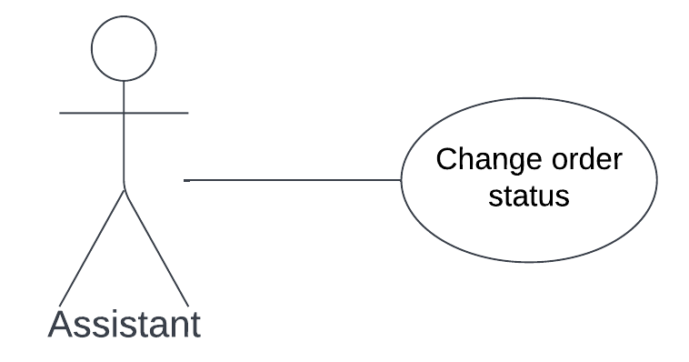
Use-Case Description:
The Assistant changes order status. (Xref: 07.X.X)
Test Case Description:
The purpose of this test case is to validate that the system allows the Assistant to change the order status without any issues. The “Change order status” Use-Case requires testing to ensure that the status of order changed in time at the request of the User authenticated as valid User role Assistant.
Test Case Specifications:
Test Case ID: Fun_04
Test Case Name: Change order status
Test Case Title: Change and verify the status of chosen order.
Test Case Priority (Low/Med/High): Low
Test Case Description: Test the “Change order status” functionality in order to detect any defects in displaying and changing the status order of the Pick-up Point.

Resources
The Testers team responsibilities, revolves around identifying each combination of main and alternate flows to help in the process of creating test cases for the “Change order status” Use-Case. The association to the test case: User role of the Assistant.

Preconditions
- The User has been authenticated and authorized as a valid User of role Assistant. (Xref: 07.X.X)

Post Conditions
- The status of order was successfully changed. (Xref: 07.X.X)

Flow of Events
Basic Path | - The Assistant clicks on the button „My Account”.  - The Terminal displays My Account Page.  - The Assistant clicks on the button „Change Order Status”.  - The Assistant chooses an order.  - The Assistant enters status of the order.  - The Assistant clicks on the button „Submit”.
Alternative Path | -
(Xref: 07.X.X)

Inclusion/Exclusion Points
Inclusion points:
Test Case ID: Fun_01
Test Case Name: Log in
Test Case Title: Log in as a valid User of role Assistant or Customer.
*in this case, User of role Assistant

Special Requirements
The Guest needs to log into the system as a valid User of role Assistant in order to use “Change order status” functionality.

Use-case scenario
Scenario Name | Starting Flow | Alternative Flow
Scenario 1 – Successful Standard | Basic Path | -

Test case “Change order status”

Scenario 1 – Successful Standard
Step | Test Steps | Test Data | Expected Result | Actual Result | Process Success (Pass/Fail) | Notes
1 | Clicks on the “My Account” button. | - | The “My Account” button should be pressed without any errors. | The “My Account” button successfully clicked | Pass | -
2 | Navigate to My Account Page. | Link: https://www.  myaccount  .com | Should be redirected to My Account Page in time without any errors. | Successfully redirected to My Account Page in time. | Pass | -
3 | Clicks on the “Change Order Status” button. | - | The “Change Order Status” button should be pressed without any errors. | The “Change Order Status” button successfully clicked. | Pass | -
4 | Navigate to Change Order Status Page. | Link: https://www.  orderslist  _assistant  .com | Should be redirected to Orders List Page in time without any errors and all orders and statuses correctly displayed. | Successfully redirected to Orders List Page in time and all orders and statuses correctly displayed. | Pass | -
5 | Clicks on the order. | Order number: #1020 | The Order number #1020 button should be pressed without any errors. | The Order number #1020 button successfully clicked. | Pass | -
6 | Write the new status. | New status: “Done” | A new status “Done” should be written without any errors. | A new status “Done” successfully written without any errors. | Pass | -
7 | Clicks button “Submit” | - | The “Submit” button should be pressed without any errors. | The “Submit” button successfully clicked. | Pass | Scenario 1 – Successful Standard

1.1 INTRODUCTION TO “VIEW THE STATUS OF THE ORDER”

Purpose of The Test Case Document
The Test Case document documents the functional requirements of the “View The status of the order” test case. The intended audience is the project manager, project team, and testing team. Some portions of this document may on occasion be shared with the client/user and other stakeholder whose input/approval into the testing process is needed.

TEST CASE “VIEW THE STATUS OF THE ORDER” SPECIFICATION

Description
The following section includes Use-Case Diagram, Use-Case Description, Test Case Description and Test Case Specifications.

Use-Case Diagram:
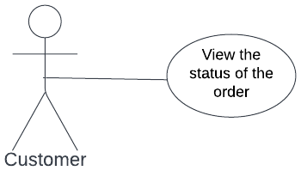
Use-Case Description:
The Customer checks the status of his orders. (Xref: 04.X.X)
Test Case Description:
The purpose of this test case is to validate that the system allows the Customer to view the list of all orders made by him without any issues. The “View the list of the order” Use-Case requires testing to ensure that correct list of orders displays in time at the request of the User authenticated as valid User role Customer.
Test Case Specifications:
Test Case ID: Fun_05
Test Case Name: View the list of the order.
Test Case Title: View the whole list of all made orders.
Test Case Priority (Low/Med/High): Low
Test Case Description: Test the “View the list of the order” functionality in order to detect any defects in displaying and viewing the correct list of all orders made by specific Customer.

Resources
The Testers team responsibilities, revolves around identifying each combination of basic and alternate flows to help in the process of creating test cases for the “View the list of the order” Use-Case. The association to the test case: User role of the Customer.

Preconditions
- The User has been authenticated and authorized as a valid User of role Customer. (Xref: 04.X.X)

Post Conditions
- The list of statuses of Costumer orders appeared on the screen.(Xref: 04.X.X)

Flow of Events
Basic Path | - The Customer clicks on the button “My Account”.  - The Terminal displays My Account Page.  - The Customer chooses the option “View Order Status”.  - The Terminal displays statuses of all customer orders.
Alternative Path | 4.a.1 The Terminal displays the empty list.
(Xref: 04.X.X)

Inclusion/Exclusion Points
Incusion points:
Test Case ID: Fun_01
Test Case Name: Log in
Test Case Title: Log in as a valid User of role Assistant or Customer.
*in this case, User of role Customer.

Special Requirements
The Guest needs to log into the system as a valid User of role Customer in order to use “View the list of the order” functionality.

Use-case scenario
Scenario Name | Starting Flow | Alternative Flow
Scenario 1 – Successful Standard | Basic Path | -
Scenario 2 – Successful Non-standard | Basic Path | Alternative Path 1

Test Case “View the status of the order”

Scenario 1 – Successful Standard
Step | Test Steps | Test Data | Expected Result | Actual Result | Process Success (Pass/Fail) | Notes
1 | Clicks on the “My Account” button. | - | The “My Account” button should be pressed without any errors. | The “My Account” button successfully clicked | Pass | -
2 | Navigate to My Account Page. | Link: https://www.  myaccount  .com | Should be redirected to My Account Page in time without any errors. | Successfully redirected to My Account Page in time. | Pass | -
3 | Clicks on the “View Order Status” button. | - | The “View Order Status” button should be pressed without any errors. | The “View Order Status” button successfully clicked | Pass | -
4 | Navigate to View Order Status Page. | Link:  https://www.  ordersstatus  _customer  .com | Should be redirected to View Order Status Page in time without any errors and all orders correctly displayed. | Successfully redirected to View Order Status Page in time and all orders correctly displayed. | Pass | Scenario 1 – Successful Standard

Scenario 2 – Successful Non-standard
Step | Test Steps | Test Data | Expected Result | Actual Result | Process Success (Pass/Fail) | Notes
1 | Clicks on the “My Account” button. | - | The “My Account” button should be pressed without any errors. | The “My Account” button successfully clicked | Pass | -
2 | Navigate to My Account Page. | Link: https://www.  myaccount  .com | Should be redirected to My Account Page in time without any errors. | Successfully redirected to My Account Page in time. | Pass | -
3 | Clicks on the “View Order Status” button. | - | The “View Order Status” button should be pressed without any errors. | The “View Order Status” button successfully clicked | Pass | -
4 | Navigate to View Order Status Page. | Link:  https://www.  ordersstatus  _customer  .com | Should be redirected to View Order Status Page in time without any errors and all orders correctly displayed. | Successfully redirected to View Order Status Page in time and all orders correctly displayed. | Pass | Scenario 2 – Successful Non-standard

APENDIX REFERENCES

The following table summarizes the documents referenced in this document.
Document Name and Version | Description | Location in Document | Name of Reference
SRS Sandwich Maker – version 5 | Software Requirements Specifications for “Sandwich Maker” System (version 5.0). | Use-Case Model Survey | Xref: 06.X.X View the list of orders
SRS Sandwich Maker – version 5 | Software Requirements Specifications for “Sandwich Maker” System (version 5.0). | Use-Case Model Survey | Xref: 02.X.X View personal data
SRS Sandwich Maker – version 5 | Software Requirements Specifications for “Sandwich Maker” System (version 5.0). | Use-Case Model Survey | Xref: 07.X.X Change order status
SRS Sandwich Maker – version 5 | Software Requirements Specifications for “Sandwich Maker” System (version 5.0). | Use-Case Model Survey | Xref: 04.X.X View the status of the order

